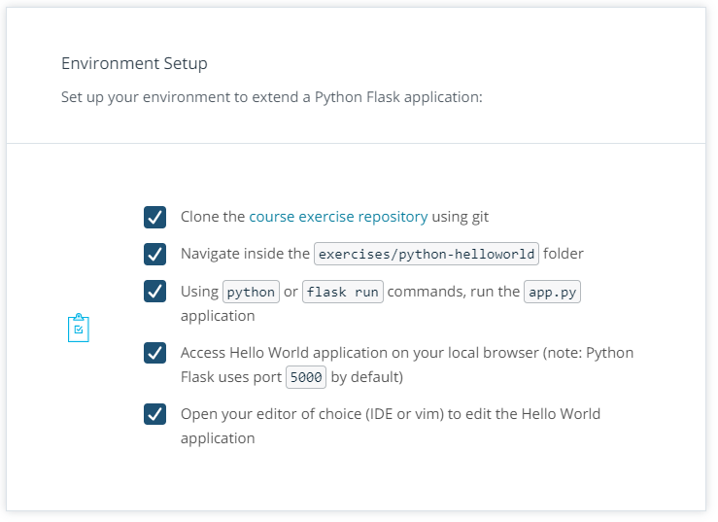

Once all the pre-requisites are completed, you can get started on developing endpoints to describe the application state.

**Exercise**

Extend the Python Flask application with /status and /metrics endpoints, considering the following requirements:

* Both endpoints should return an HTTP 200 status code
* Both endpoints should return a JSON response e.g. {"user": "admin"}. (Note: the JSON response can be hardcoded at this stage)
* The /status endpoint should return a response similar to this example: result: OK - healthy
* The /metrics endpoint should return a response similar to this example: data: {UserCount: 140, UserCountActive: 23}

Tips: If you get stuck, feel free to check the solution video where detailed operations are demonstrated.